Name: Harsh Ghaoghave PRN : 25070521179
8.1.2 Prime Numbers in a Given Range
Algorithm
Step 1: Start
Step 2: Input start and stop values
Step 3: Set f = False
Step 4: For each number num from start to stop
Step 5: If num > 1, assume it is prime (flag = True)
Step 6: Check divisibility from 2 to √num
Step 7: If divisible, set flag = False and stop checking
Step 8: If flag is True, print the number and set f = True
Step 9: After the loop, if f is False print "No primes"
Step 10: Stop
Flowchart

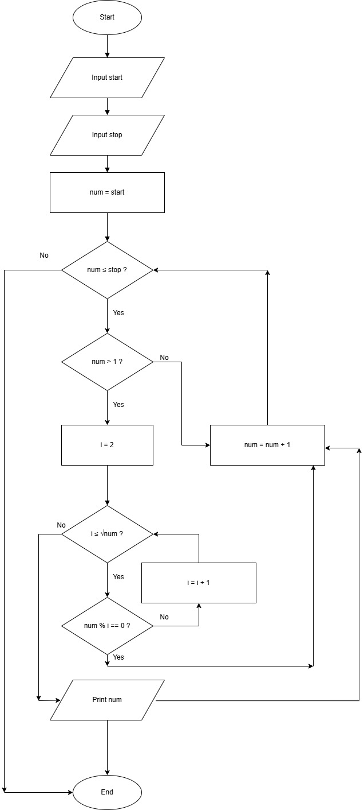

PYTHON CODE
start = int(input())
stop = int(input())

f = False

for num in range(start, stop + 1):
if num > 1:
flag = True

for i in range(2, int(num ** 0.5) + 1):
if num % i == 0:
flag = False
break

if flag:
print(num)
f = True
if not f:
print("No primes")
EXCECUTION
